[*Published with MATLAB® R2022b*](https://www.mathworks.com/products/matlab)

**SIGNALS AND SYSTEMS**

**PROJECT-03**

**DR.B NIRANJAN KRUPA**

**Name: AKASH RAVI BHAT**

**SRN:PES1UG21EC025**

**Sem:3**

**Sec:A**

%1)TO PLOT ZEROS AND POLES GRAPHS ON REAL AND IMAGINARY AXIS

clc; clear; close;

syms z;%symulize the variable

Hz=z/[z-0.5]; %to find zeros and poles

a=[1 -0.5]; %defining a

b=[1];%defining b

[z,p,k]=tf2zpk(b,a);

zplane(z,p);%to plot zeros and poles on z plane

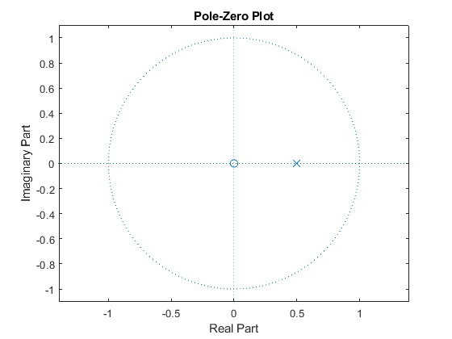

[*Published with MATLAB® R2022b*](https://www.mathworks.com/products/matlab)

%2)To find impulse response

hn=iztrans(Hz);%to find inverse z transform

disp('hn=');

disp(hn);%display h(n)

n=0:9;

h=subs(hn,n);

figure(2);% to plot impule response

stem(n,h);% dicrete time used stem

title("impulse response");

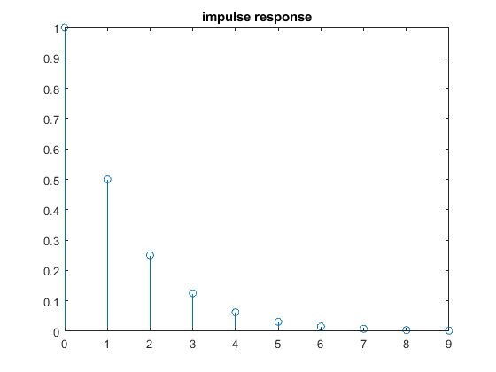

%3)to find frequency response replece z by e^jw

w=-pi:0.01:pi;%defining variable w

Hw=exp(i*w)./(exp(i*w)-0.5);

Hwmag=abs(Hw); %to find absolute value of Hw

Hwang=angle(Hw);%to find angle value of Hw

figure(3);

subplot(211);a=gca();%to plot graph in box

a.YAxisLocation="origin"

plot(w,Hwmag); % plot magnitude response

title("magnitude response");

xlabel("w");ylabel("|Hw|");%labeling the axes

subplot(212);a=gca();

a.YAxisLocation="origin"

plot(w,Hwang); %plot phase responsea

[*Published with MATLAB® R2022b*](https://www.mathworks.com/products/matlab)

title("phase response");

xlabel("w");ylabel("angle of Hw");;%labeling the axes

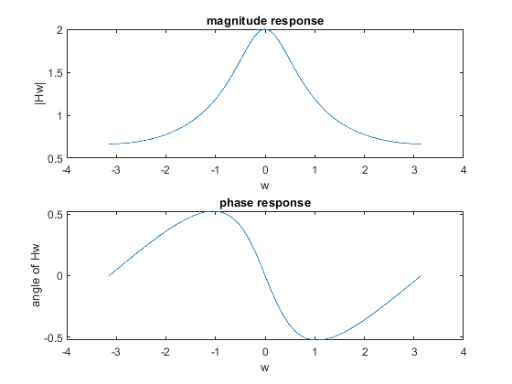

hn=  
(1/2)^n  
   
  
a =   
  
 Axes (magnitude response) with properties:  
  
 XLim: [-4 4]  
 YLim: [0.5000 2]  
 XScale: 'linear'  
 YScale: 'linear'  
 GridLineStyle: '-'  
 Position: [0.1300 0.5876 0.7750 0.3365]  
 Units: 'normalized'  
  
 Use GET to show all properties  
  
  
a =   
  
 Axes (phase response) with properties:  
  
 XLim: [-4 4]  
 YLim: [-0.5236 0.5236]  
 XScale: 'linear'  
 YScale: 'linear'  
 GridLineStyle: '-'  
 Position: [0.1300 0.1138 0.7750 0.3365]  
 Units: 'normalized'  
  
 Use GET to show all properties

[*Published with MATLAB® R2022b*](https://www.mathworks.com/products/matlab)